**DAILY ONLINE ACTIVITIES SUMMARY**

|  |  |  |  |  |  |  |  |  |
| --- | --- | --- | --- | --- | --- | --- | --- | --- |
| **Date:** | 05/06/2020 | | | | | **Name:** | RIYA CP | |
| **Sem & Sec** | IV Sem & B section | | | | | **USN:** | 4AL18CS070 | |
| **Online Test Summary** | | | | | | | | |
| **Subject** | | - | | | | | | |
| **Max. Marks** | | 30 | | **Score** | | | **-** | |
| **Certification Course Summary** | | | | | | | | |
| **Course** | Introduction to Cyber Security | | | | | | | |
| **Certificate Provider** | | | Greatlearning academy | | **Duration** | | | 7.0 hours |
| **Coding Challenges** | | | | | | | | |
| **Problem Statement1:** Write a Java Program to find the duplicate characters in a string. | | | | | | | | |
| **Status: Executed** | | | | | | | | |
| **Uploaded the report in Github** | | | | | YES | | | |
| **If yes Repository name** | | | | | Lockdown-coding | | | |
| **Uploaded the report in slack** | | | | | YES | | | |

**Online Test Summary:** No internals conducted today.

**Online Certification Course Summary:** In today’s session I have learnt about Governance and Risk in Cyber Security and also learnt about Introduction to Cryptography what exactly cryptography is and encryption.

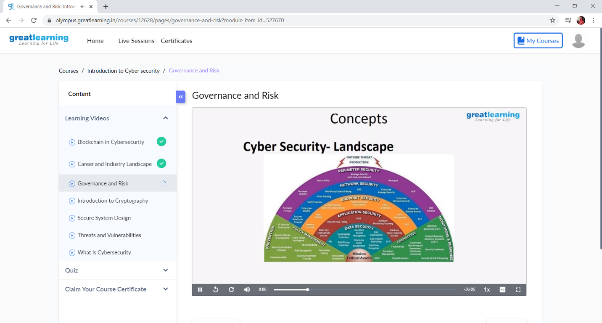

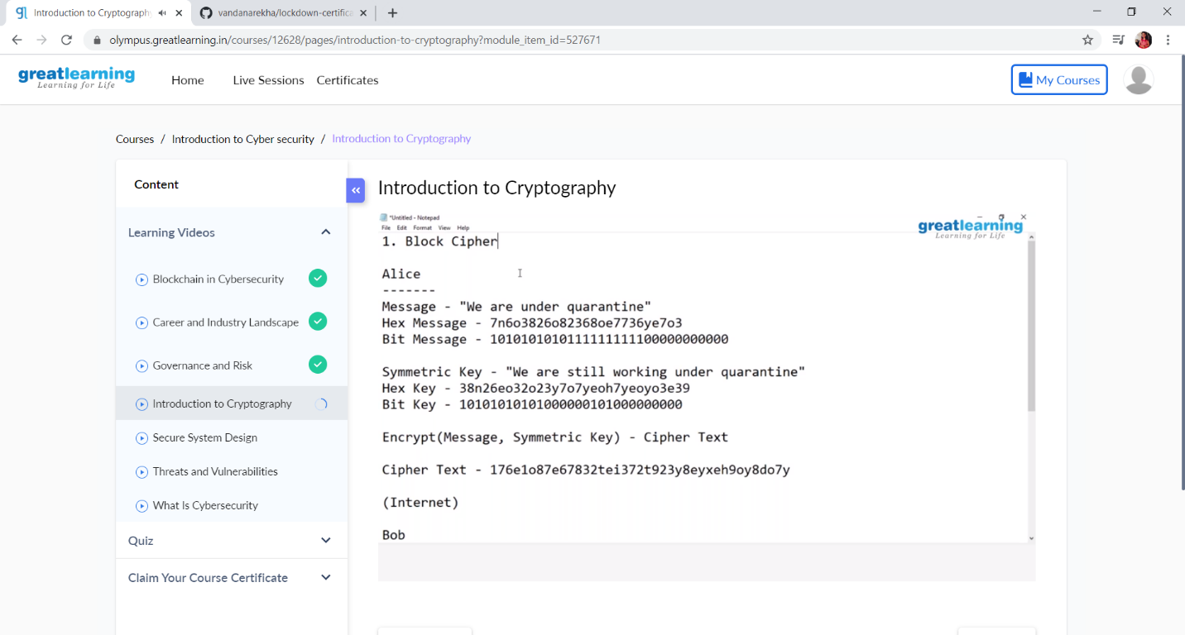

**Online Coding Summary: Today** I had received one program from prof. Reena Lobo CSE Dept. The program is mentioned above in the coding challenges (pg.01). I have also uploaded it to my Github repository.

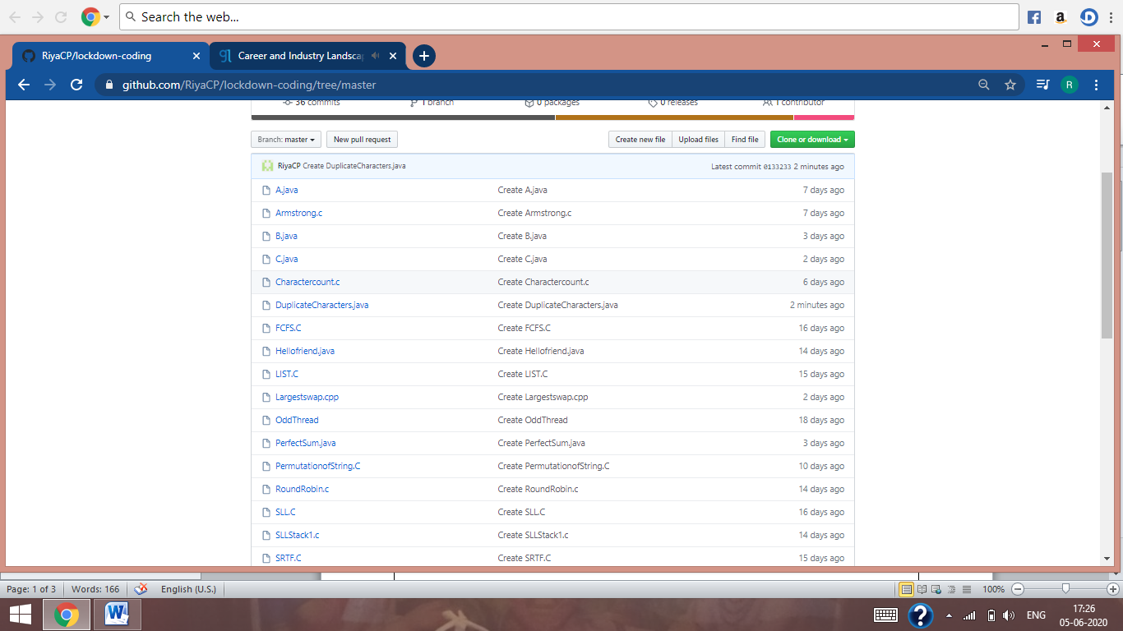

It is the snap shot of my repository were I have uploaded the code. File name is DuplicateCharacters.java